

Assignment 1 Report

Student Name: Wei Tang

Student ID: 29504449

Tutor Name: Jeffery Liu

Word Count: 898 words

Visualisation URL: <https://public.tableau.com/app/profile/diana.tang/viz/FIT3179_Assignment1_16307752413730/1?publish=yes>

# Description

The field of interest is the rainfall situation in various cities in Australia and the rainfall trend in Australia during the decade. The aim is to find the overview rainfall situations in different cities in Australia and also the rainfall trends in Australia.

The rainfall has always been a topic of concern, no matter in any aspect, such as agriculture or people’s daily travel, they will also pay attention to rainfall. Therefore, the action is to discover and present for the people who care about the rainfall in various cities and rainfall trends.

# What

The dataset contains about 10 years of daily weather observations from many locations across Australia which is authored by Joe Young. It contains the weather conditions such as humidity, temperature and sunshine, etc. The purpose of this dataset is that according to these conditions to predict next-day rain by training classification models on the specific target variable. However, in this visualisation, we only focus on the rainfall in different cities and in different years.

The top bar chart: this visualisation shows the rainfall in different cities from 2007 to 2017. The x-axis is the location which represents the categorical data and the y-axis is the summary of the rainfall which represents the quantitative data.

The second bar chart (sum-year rainfall): this visualisation shows the overall rainfall for each year in Australia. The x-axis is the year which represents the categorical data, the y-axis is the summary of the rainfall which represents quantitative data.

The line chart: this visualisation shows the average rainfall trends from 2007 to 2017 in Australia. The x-axis is the year which represents the categorical data and the y-axis is the average rainfall which represents the quantitative data.

The tree map: this visualisation through the hierarchical structure directly shows the proportion of rainfall in each city. The size of area represents the quantitative data (total rainfall).

# Why & How

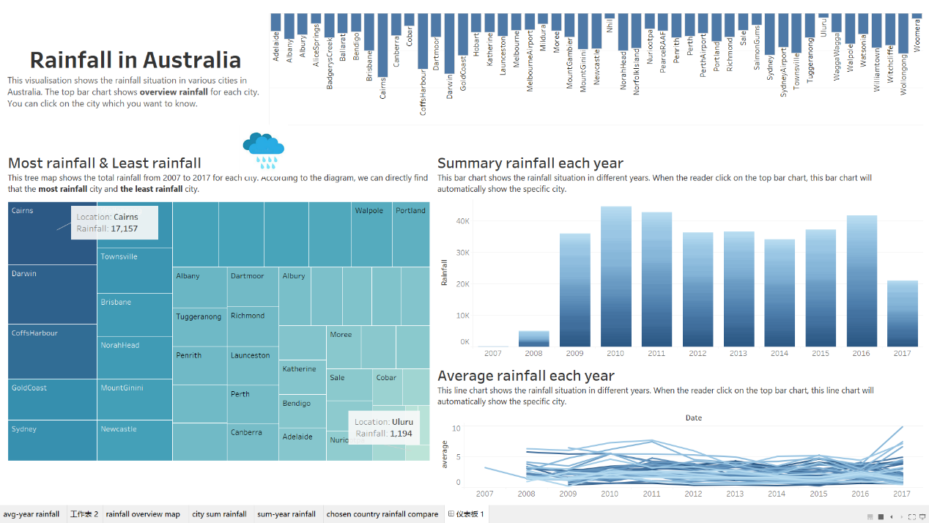

**(Figure. 1)**

The top bar chart: the mark is lines and the vertical position scale channel is used for quantitative attribute which is the total number of rainfall and the horizontal position channel is used for the categorical attribute city. The length for the bar chart is also indicated the quantitative attribute. The target is indicating the rainfall varies greatly from city to city in Australia. Additionally, this chart is used as a filter, when the user clicks the specific city, other charts will automatically change (only show the selected city information, as shown in Figure. 2)

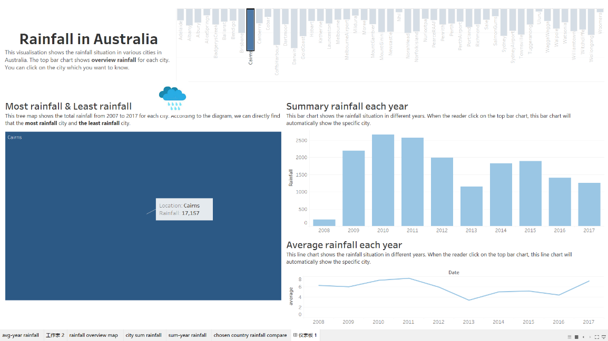

**(Figure. 2)**

The line chart: the mark is point and aligned vertical position to express the average rainfall which is the quantitative data, separate by year which is categorical data into horizontal regions. The target is figuring how Australia’s average rainfall has changed over the past decade.

The second bar chart: line is the mark which is used for this diagram. The vertical position scale channel is used for quantitative attribute which is the total rainfall and the horizontal position scale channel is used for categorical attribute which is the year. The aim is to show how much rain fell in Australia each year for a decade.

The tree map: the mark for this visualisation are areas which proportional to the quantitative attribute (total rainfall) and the categorial attribute(city) are shown as label. The colour luminance also used in this visualisation. The colour of the area varies with the size of the area, with the larger the area, the darker the colour, the smaller the area, the lighter the colour. The tree map makes the reader understand distribution of quantities throughout the hierarchy and it’s more intuitive to see the maximum and the minimum.

# Design

Layout

Let the reader read from heading and then from left to right, top to bottom. The whole layout can be divided into two parts: both the top and bottom parts are divided into equal columns. The visual centre is consistent as for each part the centre is the middle of diagram. Moreover, use the white space so that reader can easily read through.

Colour

The colour used in this visualisation is blue, white and black. The white is the background colour and it is also used for the text font same as black colour. I chose blue for the overall visualisation because it fits the theme of ‘rain’. The blue colour and its saturation represent the **quantitative data** and the white, black colour represent the **categorical data**.

Figure-ground

Increase the size of the main chart and use the title /subtitle to divide the visualisation. Meanwhile, the elements appear symmetrically on the page. As Figure.1 shown, the whole visualisation is divided into two parts and for each part, it has two descriptions.

Typography

The reason is that the Sego UI is attractive and easy to read. The heading has large font size and the important information is highlighted by using bold and the large font size which make the info more prominent.

Storytelling

The top text under the title gives a brief description for charts and tell the reader how to use the top chart as a filter to explore the data they want to see. When reader follow the structure read through (top to bottom, left to right), each chart has an introduction under the subtitle to guide the reader and describe the chart briefly.

# References

Joe, Young. (2020). Rain in Australia: *predict next-day rain in Australia.* Retrieved from <https://www.kaggle.com/jsphyg/weather-dataset-rattle-package>

# Appendix

# 

